RUSSIAN ROULLETE!
Introduction
This program simulates the dangerous and scary scenario of being trapped in a room and being forced to play this crazy game. It includes two computer plays to compete against, as well as a 4 player mode!
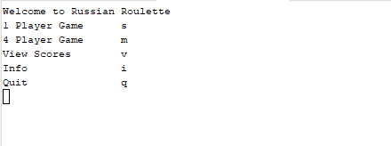
This program can also display the amount of wins and losses, as well as all the names you entered.
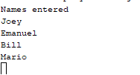
Game play And Rules: Single Player
There are two game modes currently in this simulation. There is a single player game, where you compete against two computer players. And there is a 4 player multiplayer mode. To enter single player mode, simply enter s, (not case sensitive) on the main menu. Upon starting this mode, a prompt to name players.
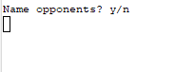
If you enter y, You are prompted to name the cpu's names. You can name them whatever you like, as long as there are no spaces, and that both names are not the same. These names you entered will be saved and used for later. How will they used for later? Well thats where the next part of this step comes in, if you select n, or anything other then y, the game will randomly pull 2 names from your names file. This processes will also insure that both names wont equal the same.

Now that you finished the name process, the game officially starts, you are informed that you start with a gun on your side. You are given three options to do.
As the promts say, entering S will promt you to shoot yourself. You will put the gun to your head, and depending on your luck and what chamber your on, you may either live or die.
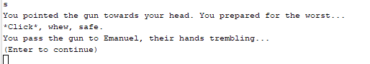
As well as shooting yourself, you can also shoot an opponent. This will bring you to another promt.
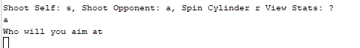
Now you must enter a valid name. A valid name would be not only the name of an opponent, but the name of an opponent whos alive.

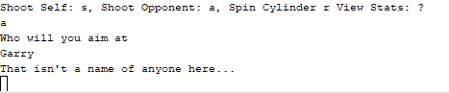
Not entering a valid name will promt you to try again until you do, this goes for entering your choice as well.
When you enter a valid name, you will attempt to shoot the opponent you choose. If your lucky, the gun will shoot the oponent, and they will be out of the game. If not, then you will be forced to shoot yourself, and this works the same as the shoot self option. Note that because you decreased the amount of blanks you have, your chances of dying increased.
The next option you have is to spin the cylinder. This randomizes the chamber per say, which could either be good or bad for you. After choosing this decision, your are forced to shoot yourself.
The last option you can enter, is to view the stats. Entering this will show you the current status of the game, mainly who is dead. This is due to text based format becoming harder to follow as the game goes on, and is more useful in multiplayer.
After you made your turn, its time for the computer to make their turn. They will make their decision based of chance. With one having more of a chance of doing a certain move over the other.

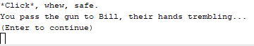
You are prompted to enter any key. This is to allow the player time to read the descriptions and understand whats going on in the game. Deepening on the computers decision, the player may be alive or dead.
Once both computer players are wiped out, or you die, the game ends. If you were to survive, you will be promoted a win message, and a win will be added to your scores.
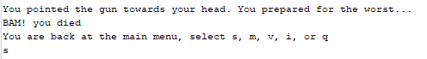
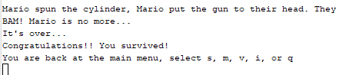
Multiplayer
Multiplayer is essentially Identical to single player, except without the cpus, and having 4 total players in the game. In the start of the game, you are prompted to enter in the names for each player. You cannot skip this option.
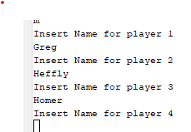
Once you entered the names, they will be saved to your names file for later use. Once you enter the game, you will be promoted the familiar prompts from single player. (Refer to singleplayer to understand the mechanices). When 3 of the 4 players have died, the remaining player will be announced as the winner. Then you will be brought back to the main menu. This will not be saved to your scores.
Miscellaneous
Lastly there is the view scores, and instructions. Simply enter v, or I accordingly, and the program will display them.
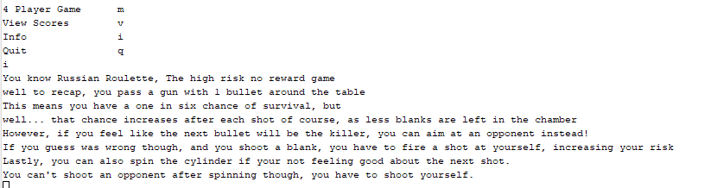
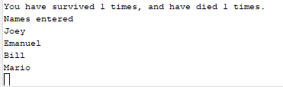
Development Process
Lines of code | 460
Lines with comments | 34
Blank Lines (White Space) | 6
Total Lines on file | 500
This project was created with IDE Netbeans. This is a continuation of project one, adding many more features that wouldn't be feasibly possible without using functions. Functions allow me to use the same code for both game modes, conserving space and rewriting code.
Added Features
As you noticed, there were a few features added from the first project. For one, the singleplayer mode has added a new computer player, making the game last longer. I also added a new move, the attack option. This adds more strategy to the game, and allows it to last longer. Another option that was added was the stats option in the game. This was added to allow easier track whats happening in the game. It also was more necessary in the new multiplayer mode. Speaking of which, multiplayer is the biggest new feature. This feature allows you to play with 4 different people.
Variables
In order to keep track of the actions and characters in the game, many variables are to be used. All variables are in their own needed functions.
Main:
char: sel
p1game:
constant float: CHAMB=6 //The max number bull can be, when its this, whoever the gun is aimed at will die
strings: com1, com2, choose, nc2a[2] //Names of computers, and nc2a is to convert the strings into an array
bools: pdie, c1die, c2die, wrong //Keeps track of which opponents died
chars: sel, cont //The input from the user
ints: bull //Keeps track of what chamber the bullet is in
floats: shoot, spin, crand //Maths that make the computers decide their actions.
p4game:
strings: p[4], choose //The players, and the input of choice
bools: pdie[4], wrong, pass //Keeping track of which players have died.
int: play, bull //Keeping track of which players turn it is currently, and bullet
char: sel; //Input selection from the user
viewsts:
fstreams: lives, names //Opens the sats and name files
ints: wins, loss //Holds the value of your wins and losses from file
strings: na //Displays the names of all entered names
shtself
constant float: CHAMB
INPUT VARIABLES:
ints: bull
bool: alive
string: name //Name of the inputed player
atta:
constant float: CHAMB
INPUT VARIABLES:
ints: &bull
bools: palive, &oAlive //Alive status of the player attacking and the player being attacked
strings: name, Opname //Name of the player attacking, and the player being attacked
satta: //Same as above, but built for singleplayer mode
constant float: CHAMB
INPUT VARIABLES:
ints: &bull
bools: oAlive
strings: opName
chars: &sel
save:
ints: wins, loss
fstreams: winloss //File where your wins and loss are stored
INPUT VARIABLES:
bools: win //Checks if you win
names:
fstreams: pnames //Opens the file where names are stored
strings:coun used as aplaceholder input to count the amount of names
ints:count //Keeps count of how many names are stored, used to create a vector.
INPUT VARIABLES:
strings: name[]
int: numbN //Number of names
smakefi:
ofstreams: newfile // Creating a new file
INPUT VARIABLES:
bools: win //Used to return to save
nmakefi:
ofstream: newfile
INPUT VARIABLES: //Used to return to names
strings: name[]
int: numbN
ranname:
fstream: pulfi
strings: temp //Used to hold the name to use
ints: count, ranam
INPUT VARIABLES:
string: def //Returns this if there arent enough names to randomize
sort:
fstream: sorfi
string: stsrt[count]
INPUT VARIABLES:
int: count
vector string: sornam
Pseudo Code
This is an example of the multiplayer code. This code demonstrates the player input, and input validation of names.
P4game:
string p[4], choose; These hold the player names, and the choice a player can make in the attack move
bool pdie[4], wrong=true; pdie holds the status of death for each player, wrong validates input
int play=0, bull; play keeps track of the current player
char sel='l'; The item that allows player input for selection
pdie[0]=pdie[1]=pdie[2]=pdie[3]=true; setting all the players as true or 'alive' to start.
while(for loop) i=0, i<4, increment i by 1{
int c=i counter for the validation check later.
Output “Input name for player (i's value +1)”
input for p[i]
while(c>0){ Checking if the names are the same
if(p[i] is equal to p[c-1]){
output “That name is already in use”
input for p[i]
c=i
}
else (they arent equal) decrement c by 1.
} end of the while loop
} End of the for loop
enter the function names, with inputs p[], 4.
output “p[0] p[1] p[2] and p[3] have entered the game”
while (at least 2 of the player die bools are true){

